Home Opener Match vs Knoxville FC
The season officially began on Saturday, March 16^{th.} Independence prepared for their first game at home vs Knoxville FC. Last year, these teams tied their three games against each other. With looming tension, the crowd was stirring to see today’s outcome. The anticipation led to an attendance of 2500, the second-highest in League 1’s opening weekend! Players arrived dressed to impress.
In preparation for the game, Coach Mike emphasized the press. He wanted the boys to message the league on their first game. They needed to get after their opponents from the very first whistle. Coach told the team to stay disciplined as they had trained this preseason. There was an expectation already for Knoxville’s midfielders, who were known to hit long balls. Independence’s tight pressure would hopefully give them less time in the center with the ball. The high pressure would also potentially limit chances for Knoxville, allowing fewer shots on goal.
First Half
The match’s starting lineup was a 4-1-4-1. Pack was in goal, with Dimick, Roberts, Speilman, and Ngah as his defenders. Ciss, Ndiaye, Alvarez, Johnson, and Mbuyu were in the Midfield. Obertan was up top as the attacker. As instructed, the boys started with the pressure high! Their opponents met them with the same pressure, both teams craving a win. Knoxville was the first to establish possession. They created their first opportunity by slipping their forward in. This was shut down by blocks from Roberts and Pack, giving Knoxville a corner. They continued pushing more players forward, but Independence’s defense was strong. Not only did they hold well, but they also created the first half’s most significant opportunity on goal. Interchanging with the midfield, Mbuyu made a breakaway on the left wing. He then cut with his right foot and hit a low shot to the keeper. With pressure and few opportunities on goal, the half ended 0-0.
Second Half
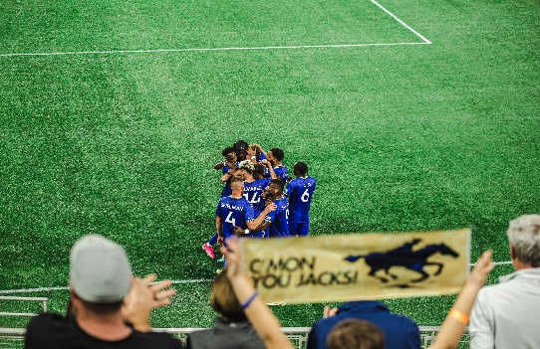
The second half began with the same starters from both teams. Knoxville held most of the possession this half. They were focusing on pressing up in attack. This led to their first goal, a combination at half field. A through ball wide led to a one-on-one. The attacker finished in the side netting. Their first goal of the season was in the books. Hoping to hold on to more of the pressure in the center and move forward, they rearranged their lineup. The coach placed the boys in a 3-5-2, creating more offensive positioning. In the 70th minute, a corner was won, and Luiz set up to kick it. Roberts gets his head on the ball, but the goalkeeper punches it out. Captain Dimick had the rebound at his feet and finished, tying the game!
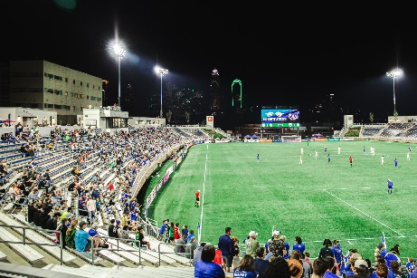
Knoxville quickly counteracted. They took back their lead within two minutes after a cross from the left. Independence kept pressing up, creating only a few more opportunities, but unable to capitalize. The game ended with a loss for Independence 2-1. Coach Mike felt responsible for not preparing the team. Independence walked away from the match, knowing that there was more for them to work on. They needed to prepare for the open cup next week. Anticipation for this match did not disappoint. Competition was high on both ends. Each team showed up ready to fight for their first win of the 2024 season.

