VS SPOKANE VELOCITY March 28
By Katelyn Snyder

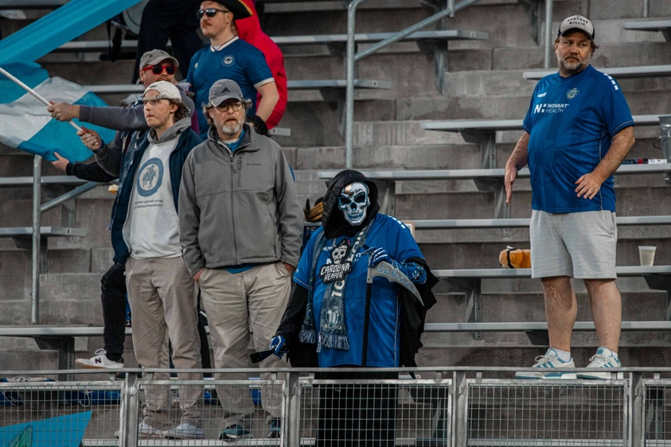
Back at home, Independence was scheduled to play Velocity on March 28. This team was ranked in the top 2 after winning both their games. They were a new team from Washington State. Although just joining the league, veterans were signed, making them experienced. Independence has been playing against younger teams so far this season, so that an older team would be a change of pace. They expect a high level of play from their opponents. Players were known to be good on the ball.

Coach Mike Jefferies emphasized pressing and staying compact. He wanted the boys to score as soon as possible. The boys were organized in a 4-3-3 formation. Pack was in goal with Sorenson, Roberts, Spielman, and Dimick as defenders. Ciss, Alvarez, and DjeDje were in the center. On top, he placed Mbuyu, Obregon, and Johnson. As the game began, their coaches' words resonated. They came in flying, eager to get an early goal. Velocity met with high intensity as well. Able to keep direct control gave Independence some trouble at first, but they adjusted their play. This allowed them to keep up with the Velocities movement.

Early on, around the 16th minute, Ciss went up for a header. He was pushed from behind by a defender. He fell on his forearm, fracturing his arm. This changed the momentum of the game. After this loss, the boys became more defensive. Off the bench, DjeDje brought quality play to the field. The game continued to be at a stalemate. Minimal opportunities on goal were made for both teams. The score remained 0-0. Although the half started with high intensity, it seemed both teams stepped back to feel each other out before truly stepping in full force.

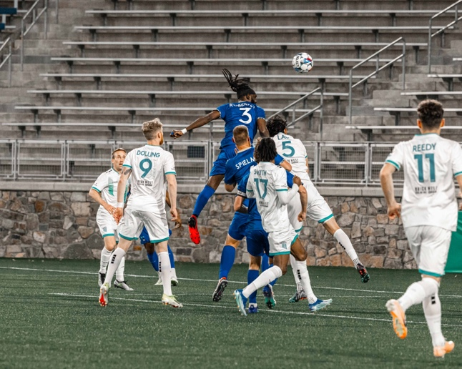
Independence inverted their formation, bringing Johnson into the middle. This helped them defensively keep more pressure on the ball. More control was brought into the center of the field. Very quickly, this switch brought Independence their first goal! From the back, the ball moved forward, and the keeper of Velocities deflected a shot on goal. Johnson was in the perfect place to receive the rebound and finish. Within the next ten minutes, velocities responded with a chance on goal. Moving down the left side of the field, they took advantage of a mishap in Independence's defense. The ball crossed over the backline. Their right-wing player beat his man and tapped the ball into goal. The score was tied 1-1.

Seeing positives from his last adjustment, Mike chose to make another change. He brought in 4 young, hungry players. They came to the field with the desire to prove themselves. In the 92nd minute, Alverez was at the top of the 18 on the right side. He cut in towards the goal with his right foot and scored a beautifully placed curve ball! He won the game for Independence. After competing in the Open Cup, the boys were excited to have a win entering back into their season. It was a close game, but the boys were excited to continue their season with a win.

